 | 26.14.2 Editors - Properties Editor - Object Data Properties Tab - Curve Object
Table of content
Detailed table of content 2
Shape panel 5
Dimensions 5
Resolution Preview U / Render U 5
Twist Method 5
Smooth 5
Fill Mode 5
Fill Deformed 5
Radius 5
Stretch 5
Bounds Clamp 6
Texture Space panel 6
Texture Mesh 6
Auto Texture Space 6
Location, Size 6
Match Texture Space 7
Geometry panel 7
Offset 7
Extrude 7
Taper Object 7
Bevel 8
Path Animation panel 10
Workflow 11
Frames 11
Evaluation Time 11
Clamp 11
Follow 11
Active Spline panel 11
Bezier curve 12
Nurbs curve 12
Poly curve 13
Shape Keys panel 13
Workflow 13
Active Shape Key Index 14
Add + 15
Remove - 15
Specials menu 15
Relative 16
Empty Hair object - Attributes Panel 17
List of Attributes 17
Add Attributes menu 17
Empty Hair object - Surface Panel 18
Surface 18
UV Map 18
Custom Properties Panel 18
Add 18
Edit 18
Remove 18

Detailed table of content
Detailed table of content
Detailed table of content 2
Shape panel 5
Dimensions 5
Resolution Preview U / Render U 5
Twist Method 5
Smooth 5
Fill Mode 5
Fill Deformed 5
Radius 5
Stretch 5
Bounds Clamp 6
Texture Space panel 6
Texture Mesh 6
Auto Texture Space 6
Location, Size 6
Match Texture Space 7
Geometry panel 7
Offset 7
Extrude 7
Taper Object 7
Taper Radius 8
Map Taper 8
Bevel 8
Depth 8
Resolution 8
Object 9
Fill Caps 9
Preset 9
Navigation elements 9
Zoom in / out 9
Tools menu 9
Reset View 9
Reset Curve 9
Reverse path 9
Toggle Profile Clipping 9
Curve Window 9
Curve point menu elements 9
Handle types 9
X / Y 9
Delete points 10
Sample straight edges 10
Sample even lengths 10
Start & End Mapping 10
Bevel Start/End 10
Bevel Mapping Start/End 10
Resolution 10
Segments 10
Spline 10
Path Animation panel 10
Workflow 11
Frames 11
Evaluation Time 11
Clamp 11
Follow 11
Active Spline panel 11
Bezier curve 12
Cyclic U 12
Resolution U 12
Interpolation Tilt 12
Radius 12
Smooth 12
Nurbs curve 12
Cyclic U 12
Bezier 12
Endpoint U 12
Order U 12
Resolution U 13
Smooth 13
Poly curve 13
Cyclic U 13
Smooth 13
Shape Keys panel 13
Workflow 13
Active Shape Key Index 14
Shape Key name 14
Slider value 14
Lock 14
Drag Handler 15
Search Field 15
Invert 15
Sort by Name 15
Add + 15
Remove - 15
Specials menu 15
New Shape From Mix 15
Mirror Shape Key 15
Mirror Shape Key (Topology) 15
Join as Shapes (Transfer Mix) 15
Transfer Shape Key 15
Delete all Shape Keys 16
Move to Top 16
Move to Bottom 16
Move Shape Key Up / Down 16
Relative 16
Relative 16
Shape Key Lock (pin icon) 16
Shape Key Edit Mode (edit mode icon) 16
Value 16
Range 16
Vertex Group 16
Relative To 16
Absolute 17
Shape Key Lock (pin icon) 17
Shape Key Edit Mode (edit mode icon) 17
Re-Time Shape Keys (clock icon) 17
Interpolation 17
Evaluation Time 17
Empty Hair object - Attributes Panel 17
List of Attributes 17
Add Attributes menu 17
radius 17
color 17
Custom 18
Empty Hair object - Surface Panel 18
Surface 18
UV Map 18
Custom Properties Panel 18
Add 18
Edit 18
Remove 18

Shape panel

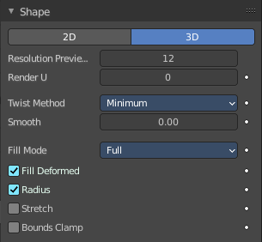
Curve shape related settings.

Dimensions
By default, new curves are set to be 3D, which means that control points can be placed anywhere in 3D space. Curves can also be set to 2D which constrain the control points to the curve’s local XY axis.

Resolution Preview U / Render U
Defines the number of points between control points. Control points are the points with the handles.
The Preview U setting defines the resolution in the 3D Viewport while the Render U setting defines the render resolution of the curve. If Render U is set to zero (0), then the Preview U setting is used for both the 3D Viewport and render resolution.

Twist Method
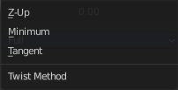
A 3D curve has control points that are not located on the curve’s local XY plane. This gives the curve a twist which can affect the curve normals. The three available methods to calculate this twist is Minimum, Tangent and Z-Up.

Smooth
Interactively removes twists from the curve by smoothing tangents.

Fill Mode
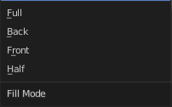
Fill mode defines the way a curve is displayed when it is beveled.

Fill Deformed
Fills the curve after applying all modification that might deform the curve. Shape keys and modifiers for example.

Radius
Causes the deformed object to be scaled by the set curve radius. Utilized when using a curve as a path or when using the Curve Modifier.

Stretch
The Stretch curve option allows you to let the mesh object stretch, or squeeze, over the entire curve. To get the expected result, use this together with the Bounds Clamp option. Utilized when using the Curve Modifier.

Bounds Clamp
When this option is enabled, the object and mesh offset along the deformation axis is ignored. This can be useful with the Stretch option or when using a negative axis. Utilized when using the Curve Modifier.

Texture Space panel

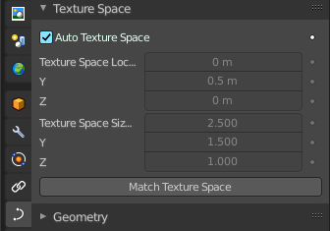
UV mapping can be generated. A procedural brick texture uses generated UV space for example to define the mapping.
In this panel you can adjust settings of the texture space used by generated texture mapping.
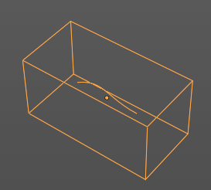



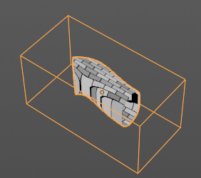

The display of the texture space cage can be activated in the Viewport Display in the Object properties.

Texture Mesh
Use another curve for texture indices. The vertex of the two objects must be perfectly aligned. Otherwise the UV map will be distorted. Note that, this is only for mesh objects.

Auto Texture Space
Adjusts the active object’s texture space automatically when transforming the object.


Location, Size
Adjust the location and size of the texture space manually if Auto Texture Space is off.

The texture space can also be adjusted in the 3D Viewport. See Object Menu / Transform / Move and Scale Texture Space

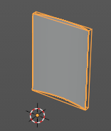
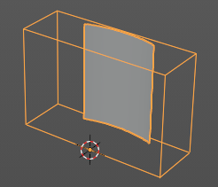
Match Texture Space
Match the texture space to the bounding box of the mesh part of the surface object, not the cage.

Geometry panel
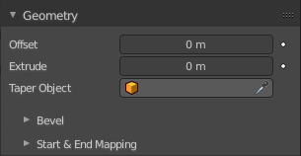
A curve is a spline. And has by default no geometry. But it can have extruded or beveled geometry. This panel allows you to adjust the geometry.

Offset
Moves the extrusion parallel to the curve normals. Needs extruded geometry first.

Extrude
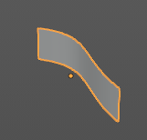
Extrude the curve along the positive and negative local Z axes to create a surface. The extrusion direction follows the curve normals.

Taper Object
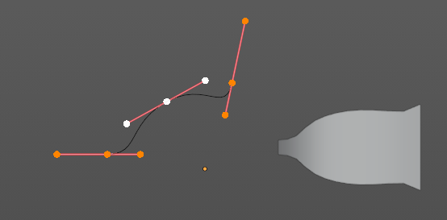
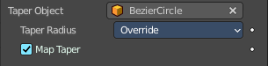
Tapers the extruded geometry by using another curve. The taper shape is defined by the Z value of the curve points of the taper object curve. Which you need to manipulate in edit mode.
You might want to rotate the taper object curve by x around 90 degrees to see the shape of the curve in the same view than at the extruded geometry.

The taper object curve:

- Must be an open curve.
- The taper is applied independently to all curves of the extruded object.
- Only the first curve in a Taper Object is evaluated, even if you have several separated segments.
- The scaling starts at the first control point on the left and moves along the curve to the last control point on the right.
- Negative scaling, (e.g. negative local Y on the taper curve) is possible as well. However, rendering artifacts may appear.
- Might need to increase the curve resolution to see more detail of the taper.

With closed curves, the taper curve in Taper Object acts along the whole curve (perimeter of the object), not just the length of the object, and varies the extrusion depth. In these cases, you want the relative height of the Taper Object Taper curve at both ends to be the same, so that the cyclic point (the place where the endpoint of the curve connects to the beginning) is a smooth transition.

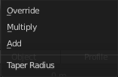
Taper Radius
How the radius of the spline point is computed.

Map Taper
For curves using a Taper Object and with modifications to the Start/End Bevel Factor. The Map Taper option will then apply the taper to the beveled part of the curve, and not the whole curve.

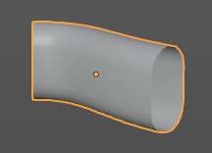
Bevel
A curve can not only be extruded, but the extruded geometry can also be beveled to give it a thickness.

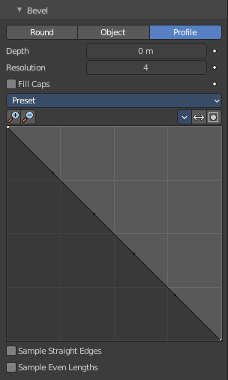
There are three bevel methods available. Round adds a rounded bevel. Object adds a bevel in the shape of a chosen object. Profile adds a bevel in the shape of the adjusted curve.
The curve settings becomes active when you have a depth value higher than 0.
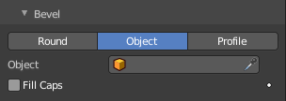
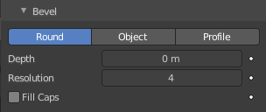

Depth
The size of the bevel.

Resolution
The subdivision of the bevel.

Object
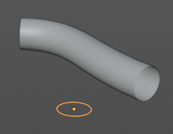
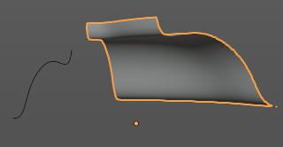
Use another curve object to define the shape of the bevel. This curve can be closed, a Bezier circle for example. Or open. Which creates an open bevel shape then.

Fill Caps
Fills the ends of a beveled curve created by another curve object. And creates a solid object.

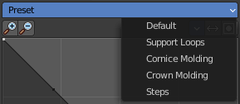
Preset
Type Profile. Curve presets.

Navigation elements

Zoom in / out
Zooms in or out in the curve view.

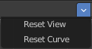
Tools menu

Reset View
Zooms to 100%.

Reset Curve
Resets the curve.

Reverse path
Reverses the path.

Toggle Profile Clipping
Clamp the values for a curve point between 0 and 1.

Curve Window
Allows you to modify the curve by dragging the existing curve points and adding new curve points. Adding a curve point can be done by clicking left at the curve. Selected curve points reveals further functionality below the curve window.

Curve point menu elements

Handle types
Adjust the handle type of the current active curve point.

X / Y
The current position of the active curve point.

Delete points
Delete this curve point.

Sample straight edges
Sample edges with vector handles.

Sample even lengths
Sample edges with even lengths.

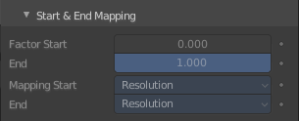
Start & End Mapping

Bevel Start/End
Where to start and to end the bevel relative to the curve. Allows to make a beveled curve which is not fully covered with a bevel.
Increasing the Start Bevel Factor to 0.5 will start beveling the curve 50% of the distance from the start of the curve (in effect shortening the curve). Decreasing the End Bevel Factor by 0.25 will start beveling the curve 25% of the distance from the end of the curve (again, shortening the curve).

Bevel Mapping Start/End
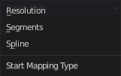
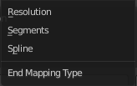
Allows to control the relation between bevel factors (number between 0 and 1) and the rendered start and end point of a beveled spline. Map the bevel factor to:

Resolution
To the number of subdivisions of a spline (U resolution).

Segments
To the length of its segments. Mapping to segments treats the subdivisions in each segment of a curve as if they would have all the same length.

Spline
The length of a spline.

Path Animation panel

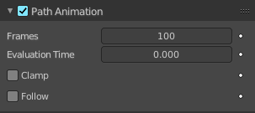
Move child objects along a path.
Note! This feature is deprecated, but still available. A more future-proof method is the Follow Path Constraint.

Workflow
Create a curve. Create an object that you want to move along the path.
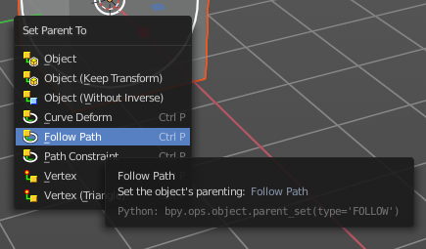
Select the object, hold down shift, and parent the object to the curve with the method Follow Path. When you press play then the object will just rotate around itself.

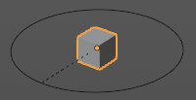

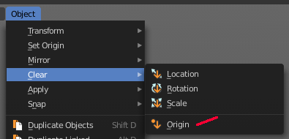
Next select the object, and clear the origin. This will set the object to the start point of the curve. And when you play the animation, then the cube will now move along the curve.
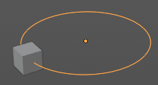

Frames
The number of frames that are needed to move along the path.

Evaluation Time
The current frame position. The position is calculated by dividing the frames through the path length.

Clamp
Clamp the curve path children so that they can't travel past the start and end point of the curve.

Follow
Make the child object rotate along the curvature of the path.

Active Spline panel

The Active Spline panel is used in Edit Mode to control properties of the currently selected spline. The tool set for Nurbs curves, Bezier curves and Poly curves differs.
Poly curves can be created by converting mesh geometry to a curve. U stands for the curve direction.

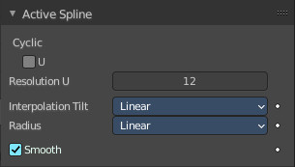
Bezier curve

Cyclic U
Closes the active spline.

Resolution U
Alters the resolution of each segment by changing the number of subdivisions.

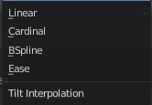
Interpolation Tilt
How the tilt of a segment is calculated.

Radius
Alters how the radius of a beveled curve is calculated. The effects are easier to see after increasing the radius.

Smooth
Use Smooth Shading for any 3D geometry.

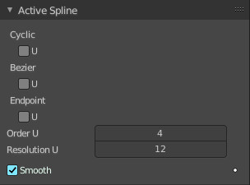
Nurbs curve

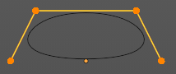
Cyclic U
Closes the active spline by connecting the end with the start point.

Bezier
Make the nurbs curve or surface act like a Bezier spline in the U direction. Order U must be 3 or 4, and Cyclic U must be disabled.

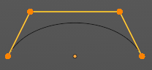
Endpoint U
Make the end points of the curve meet the end points of the handlers.

Order U
The area of influence of the control points over the curve. Higher order values means that a single control point has a greater influence over a greater relative proportion of the curve. The valid range of Order values is 2-6, depending on the number of control points present in the curve.
Two, three, four ...

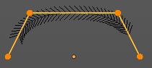
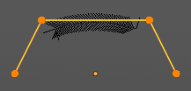
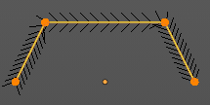

Resolution U
Alters the resolution of each segment by changing the number of subdivisions.

Smooth
Use Smooth Shading for any 3D geometry.

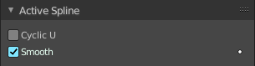
Poly curve
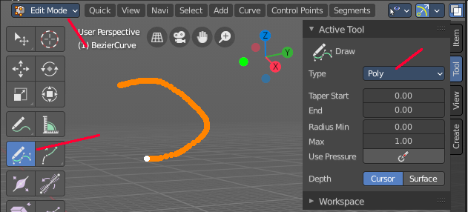
To see this content you need to be in edit mode, and draw a curve with type poly.

Cyclic U
Closes the active spline.

Smooth
Use Smooth Shading for any 3D geometry.

Shape Keys panel

This panel allows you to see and manage shape keys. A shape key is a vertex animation.
Shape keys are for example used for facial animations, when you don't want to use a face rig with bones. The idea is to model a shape key pose for smiling, one for laughing, one for sad, and so on. And then blend the shape key poses together as needed.

Shape keys are also called morph targets or blend shapes.

Workflow
In Object mode add a shape key. This first shape key is called Basis by default. It is the base for the vertex animation. This basis shape key is the base shape for all further shape keys. It cannot be modified or keyframed.

Now add a second shape key. This second shape key will have more controls so that you can modify it in the needed way.


Enter edit mode with this key 1 selected.
Modify the geometry by moving some vertices around. Shot is from a mesh, but works the same with curves.
Switch back to Object mode.


Have a look at the value slider. This slider defines how the key 1 shape key blends with the Basis shape key.
Move it from value 0 to value 1. You will notice that the vertices that you have modified in Key 1 will now start to move to a new position. Dependent of how strong the value is. With a value of 1 it will be at the position of how you modeled it.

To keyframe this shape click at the Animate property dot behind the slider. The slider will change its color. And the dot will change to a rhombus shape to indicate that there is a keyframe recorded at this frame.
Or you right click at the slider, and choose Insert Keyframe in the menu.
Move to another frame. Change the slider value, and set another keyframe.

Recorded keyframes can be found and further tweaked in the Dope sheet Editor in Shape Key Editor mode. Here you can also record further keyframes under Key / Insert Keyframes. And control the slider values from the channel list.
Add more shape keys and model and animate them as you need them.


Active Shape Key Index
A List of the shape keys for this mesh.
It contains two types of shape keys. Basis is the base shape. The other type relies at this shape as the base.

Shape Key name
The name of the shape key. It can be renamed by double clicking at it.

Slider value
The blend value of this shape key. The Basis shape key does not have such a slider.

Lock
The lock icon at the end of a group name locks the group from being editable.

Drag Handler
The two vertical lines at the end is a handler with which you can expand the list.

Search Field

You can expand a search field at the bottom of the list. Type in your term and hit enter to filter for your term.

Invert
Exclude the search term instead of searching for it.

Sort by Name
Sort the List by name.

Add +
Create a shape key.

Remove -
Delete the selected shape key.


Specials menu

New Shape From Mix
Add a new shape key with the current deformed shape of the object.

Mirror Shape Key
Mirror the shape keys on the X axis. This will not work if the mesh vertices is not fully symmetrical.

Mirror Shape Key (Topology)
Mirror the shape keys on the X axis. But detects the mirrored vertices based on the topology of the mesh. The mesh vertices do not have to be perfectly symmetrical for this action to work.

Join as Shapes (Transfer Mix)
Transfer the current resulting shape from a different object.
Select the object to copy, hold down Shift, then the object to copy into. Use this action and a new shape key will be added to the active object with the current mix of the first object.

Transfer Shape Key
Transfer the active shape key from a different object regardless of its current influence.
Select the object to copy, hold down Shift, then the object to copy into. Use this action and a new shape key will be added to the active object with the active shape of the first object.

Delete all Shape Keys
Delete all shape keys at this mesh.

Move to Top
Move the shape key to the top of the list. But not above the Basis shape key.

Move to Bottom
Move the shape key to the bottom of the list.


Move Shape Key Up / Down
Moves the selected shape key up or down in the list.

Relative
Set the shape keys to Relative or Absolute.


Relative
The shape is defined relative to the Basis or another specified shape key. And can be adjusted in its settings.

Shape Key Lock (pin icon)
Show the active shape in the 3D Viewport without blending. Shape Key Lock gets automatically enabled while the object is in Edit Mode.

Shape Key Edit Mode (edit mode icon)
If enabled, when entering Edit Mode the active shape key will not take maximum influence as is default. Instead, the current blend of shape keys will be visible and can be edited from that state.

Value
The weight of the blend between the shape key and its basis key. 0 means no influence, 1 full influence.

Range
Minimum and maximum range for the influence value of the active shape key.

Vertex Group
Limit the active shape key deformation to a vertex group.

Relative To
Select the shape key to deform from. It does not need to be the Basis shape key, but can also be another shape key.

Absolute

The shape changes over time, as defined in its settings.

Shape Key Lock (pin icon)
Show the active shape in the 3D Viewport without blending. Shape Key Lock gets automatically enabled while the object is in Edit Mode.

Shape Key Edit Mode (edit mode icon)
If enabled, when entering Edit Mode the active shape key will not take maximum influence as is default. Instead, the current blend of shape keys will be visible and can be edited from that state.

Re-Time Shape Keys (clock icon)
Absolute shape keys are timed, by order in the list, at a constant interval. This button resets the timing for the keys. Useful if keys were removed or re-ordered.


Interpolation
The interpolation method between shape keys.

Evaluation Time
Evaluate the shape key influence over the defined time. The evaluation starts at influence 0, and reaches 1 at the end of the value of this timer.

Empty Hair object - Attributes Panel

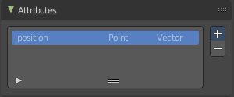
The empty hair object is a special curves object. You control it by geometry nodes.
The Attributes panel allows you to define Attributes for this purpose, which can then be used in the geometry nodes. By default just the position attribute is added.

List of Attributes
The list of available attributes.

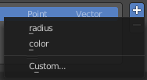
Add Attributes menu

radius
Add a radius attribute.

color
Add a color attribute.

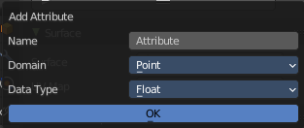
Custom
Add a custom attribute.
This opens a dialog where you can adjust the parameters of this custom attribute.

Empty Hair object - Surface Panel

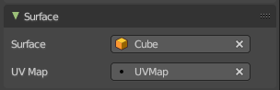
The empty hair object is a special curves object. You control it by geometry nodes.
Define the object that is used as the parent object for the hairs.

Surface
Which object to use.

UV Map
Which UV map of the object to use.

Custom Properties Panel


Here you can define custom properties that can be used for scripting.
Here you might also find custom properties from addons or scripts.

Add
Adds a new property.


Edit
Opens a panel where you can adjust the settings for the custom property.

Remove
Removes the property.

